1. What is a friend function / method ?

**A. It is permitted full access to private and protected members of a class**

b. It creaates an object by initializing it with an object of the same class, which has been created previosly

c. it is a special function / method in a class that is called when a new object of the class is created

e. it is used to expand the code in the body of the function / method in place of a call to the function / method

2.

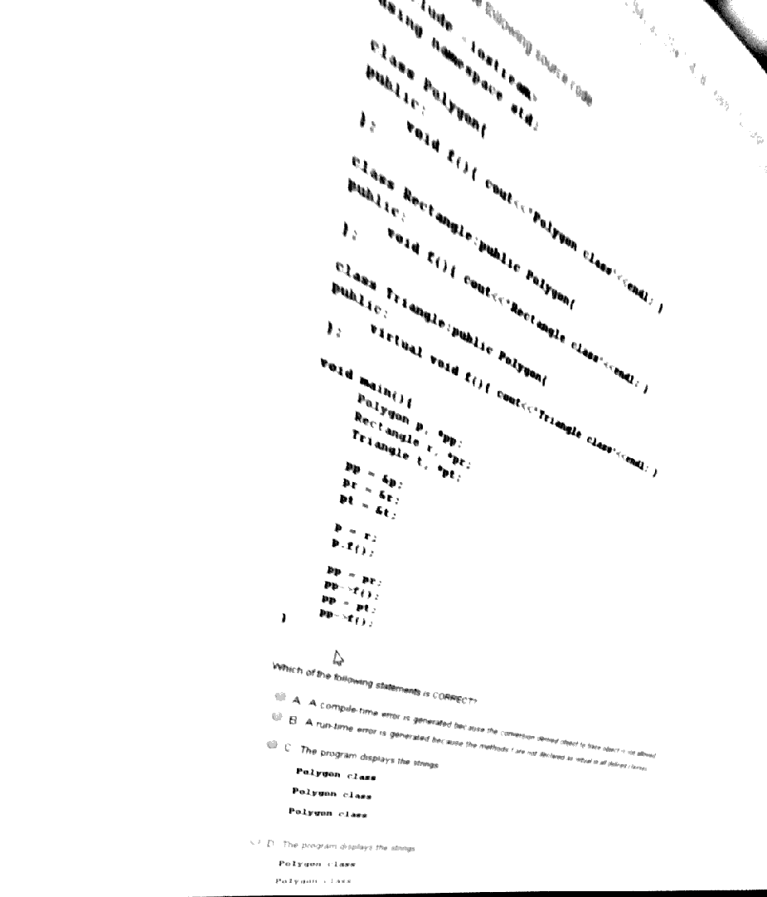

3. Choose all correct statements about the char type in java:

**a) Default value is \u0000**

**b) has 2bytes**

c) default value is true

d) default value is null

e) has 1 byte

4.It considers the following OpenSSL function call RSA\_private\_encrypt(sizeof(finalDigest), buf, e\_data, apriv, RSA\_PKCS1\_PADDING). The private key has a length of 1024 bits. Which of the following statements is CORRECT?

A. RSA\_PKCS1\_PADDING has the same length with the private key;

B. sizeof(finalDigest) represents the digest of the message;

C. A compile-time error is generated because the function has other header;

D. RSA\_PKCS1\_PADDING is a parameter specifying the padding type;

E. RSA\_PKCS1\_PADDING is a parameter specifying the padding length;

5.Which one from the next Java statements it CORRECT:

A. abstract classes can be instantiated in objects;

**B. abstract classes can contain non-abstract methods and instance variables;**

C. All these statements are NOT correct in Java

D. interfaces can NOT be used as reference type;

E. interfaces can contain instance variables

6. Which methods will every class contain ?

**a) constructor + destructor**

b) getter+setter

c) -

d) -

7. Given

class Base

{ static { System.out.print("b1 ");} // static init block – executed once { System.out.print("b2 ");} // instance init block – executed for every object created public Base(){ System.out.print("b3 "); } } class Subclass extends Base{ public Subclass(){ System.out.print("s1 "); } } public class Main { public static void main(String[] args) { System.out.print("main "); new Base(); new Subclass(); } }

what is the result ?

A. main b1 s1 b2 b3

B. main b2 b3 s1 b1 b2 b3

C. main b1 b3 s1 b2 b3

D. main b1 b2 b3 s1 b2 b3

E. main b1 b2 b3 b2 b3 s1

F. it can't be determined

G. b1 main b2 b3 s1 b2 b3

8. What a destructor return ?

a) -

b) -

c) -

d) -

e) -

9. It considers the following source code:

#include <stdio.h>

#define NMAX 100

#define then

#define BEGIN { #define END } #define INTEGER int

void main() BEGIN INTEGER S = 0; INTEGER vector[NMAX]; for(INTEGER i=0; i<NMAX; i++) vector[i]=i+1; for(INTEGER i=0; i<NMAX; i++) S+=vector[i]; printf("S= %d",S); END At run-time, the result of the above application is:

A. 50;

B. 0;

C. 5050;

D. The application generates a run-time error;

E. The source code cannot be compiled;

---------------------------------------------------------------------------------------------------------------------------

De aici incep intrebarile care sunt asemanatoare dar nu garantez ca sunt identice cu cele de la examen .

10 .

11. Aici era modificat prodDate = 20160104

12.

13.

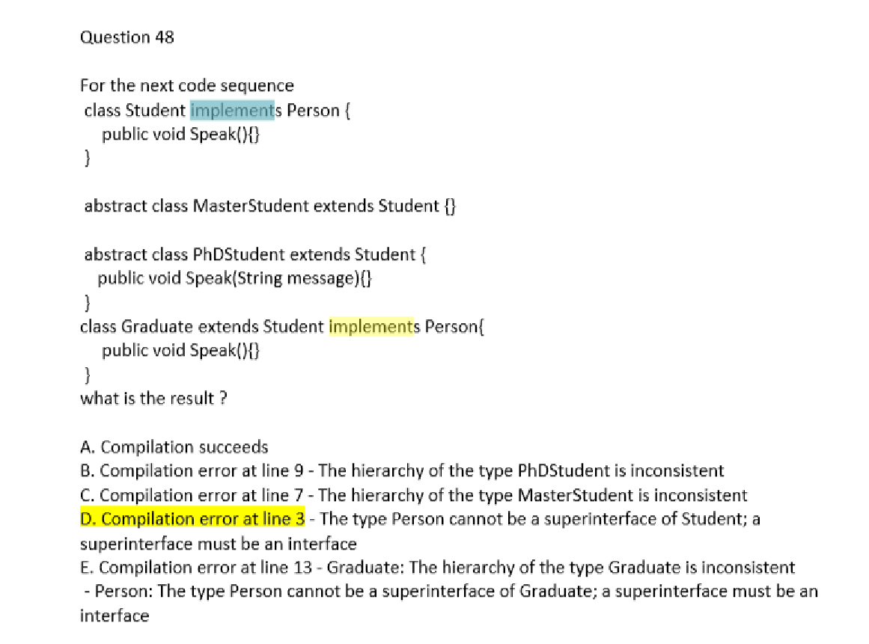

14.

15.

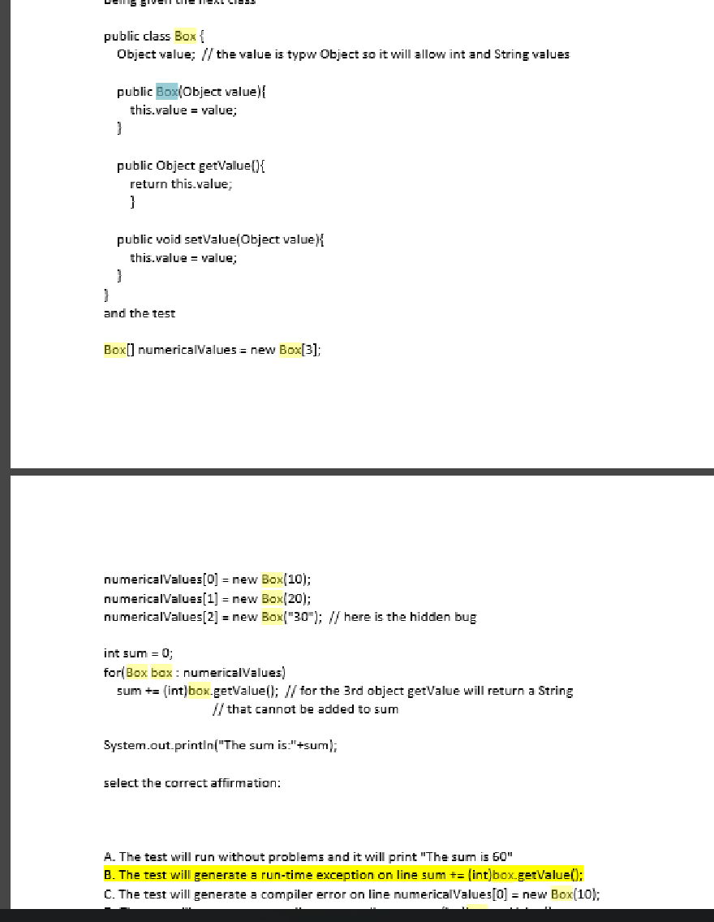

16.

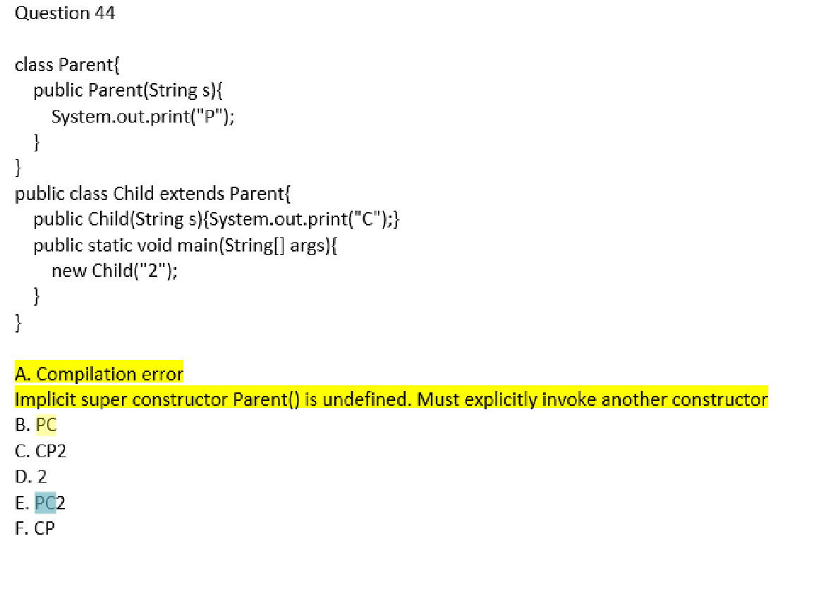

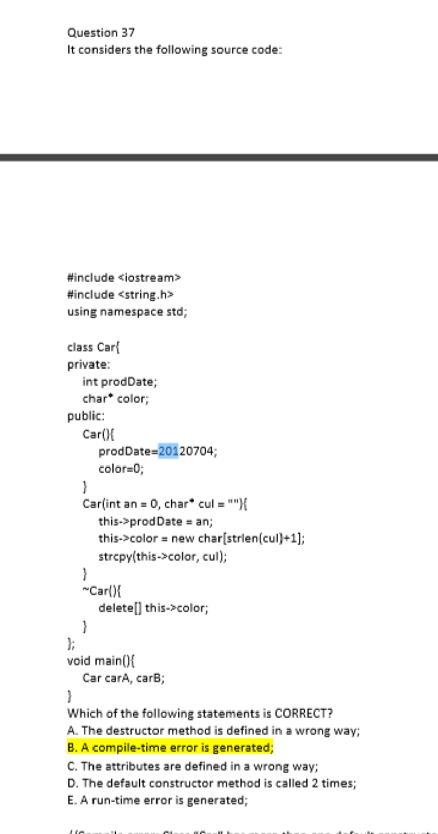

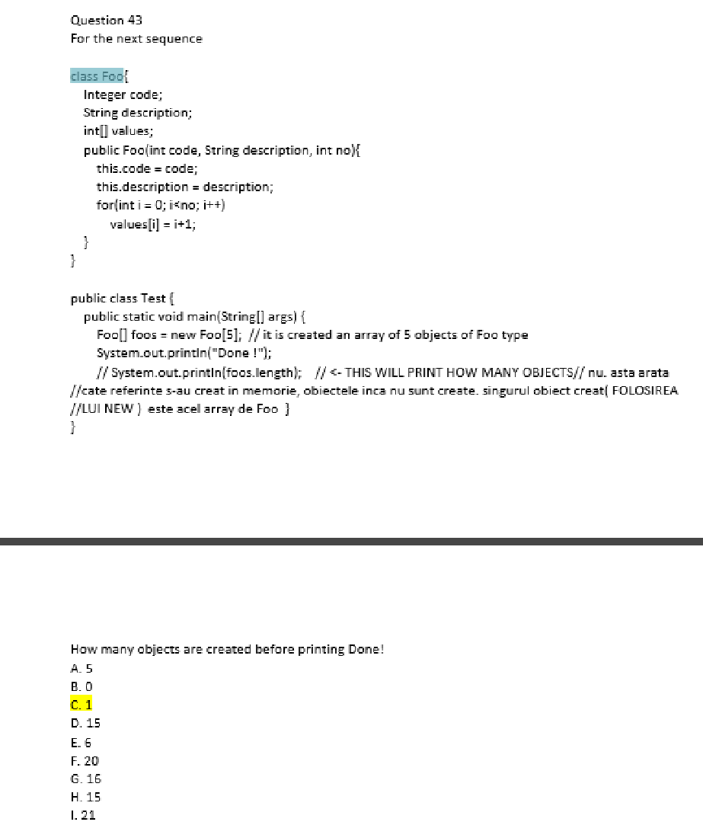

16667952_1347416785279354_1513815004_o.jpg